Black-Litterman

A) Black-Litterman formulas and description

B) Black-Litterman for Token Metrics  
  
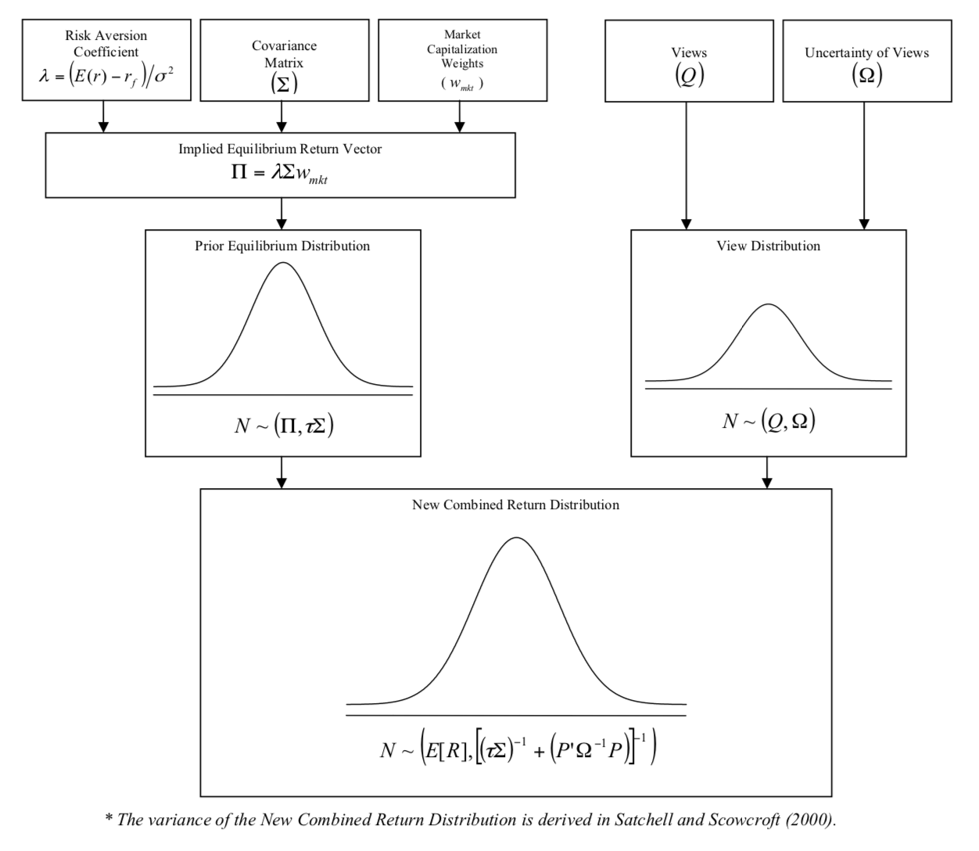

## Black-Litterman Formulas and Description

1. Black-Litterman uses “equilibrium returns” as a starting point

**∏ = 𝝀 * 𝝨 * w(mkt)**  
  
**∏**: is the Implied Excess Equilibrium Return Vector (Nx1 column vector)  
**𝝀:** is the risk aversion coefficient  
**𝝨:**  is the covariance matrix of excess returns (NxN matrix)  
**w(mkt):** is the market capitalization weight of the assets (Nx1 column vector)

To get **𝝀:** Get historical risk premium of assets **( E(R) - R_f )** then divide by variance of excess returns of the benchmark (market) 𝞼**^2.**   
  
So  **𝝀 = ( E(R) - R_f ) / (** 𝞼**^2 )**

## The Black-Litterman Formula

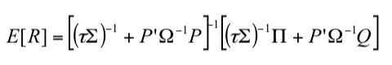  
  
**E(R):** is the new (posterior) Combined Return Vector (Nx1)  
**𝞽** : is a scalar (hard to determine but usually between 0.01 and 0.05)  
**𝝨**: is the covariance matrix of excess returns (NxN matrix)  
**P:** is a matrix that identifies the assets involved in the views (KxN matrix)

**K:**  is the number of views  
**𝞨:** is a diagonal covariance matrix representing the uncertainty in each view (KxK matrix)  
**∏:** is the implied equilibrium return vector (Nx1)  
**Q:**  is the View Vector (Kx1 vector)

## Building the Inputs

Consider these views:  
  
View 1: Asset 1 will have an absolute excess return of 5.25% (Confidence of view = 25%)  
View 2: Asset 2 will outperform Asset 1 by 0.25% (Confidence of view = 50%)

View 3: Asset 3 and 5 will outperform Asset 4 and 6 by 2% (Confidence = 65%)

Since we have 3 views, the views vector has K=3 rows

The uncertainty of views is normally-distributed error term vector ( **ε** ) with a mean of 0 and covariance matrix **𝞨.**

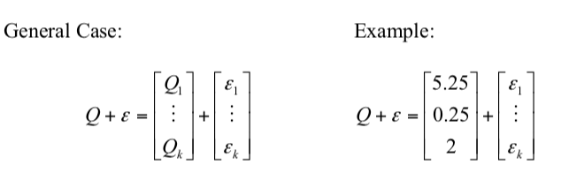

The expressed views in vector **Q** are matched to specific assets by matrix **P.**   
  
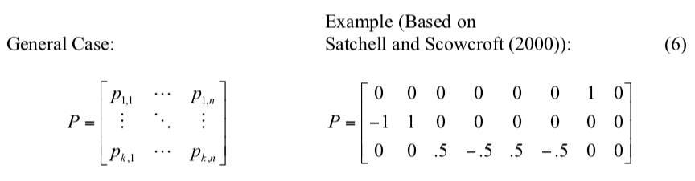

For Token Metrics, matrix P is an identity matrix since we give absolute views for each asset in the portfolio.

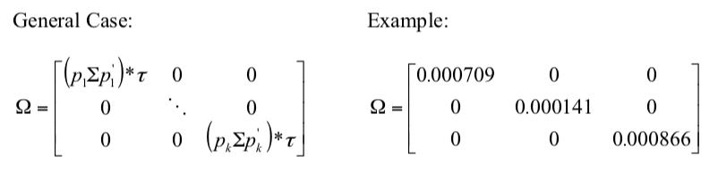

**Having specified the scalar (𝞽) and the covariance matrix of the error term (𝞨), all of the inputs are entered into the Black-Litterman formula and the New Combined Return Vector ( E[R] ) is derived.**

After we get our views and uncertainty matrix, we update our expected return vector:  
  


And update our covariance matrix:  
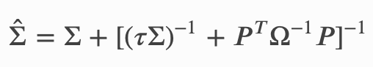

Then get the optimal Black Litterman weights:  
  
**W = ( 𝝀 * 𝝨 )^(-1) * E[R]**

Incorporating views to TM

For Token Metrics, consider views related to top10TM and MCap Rank:

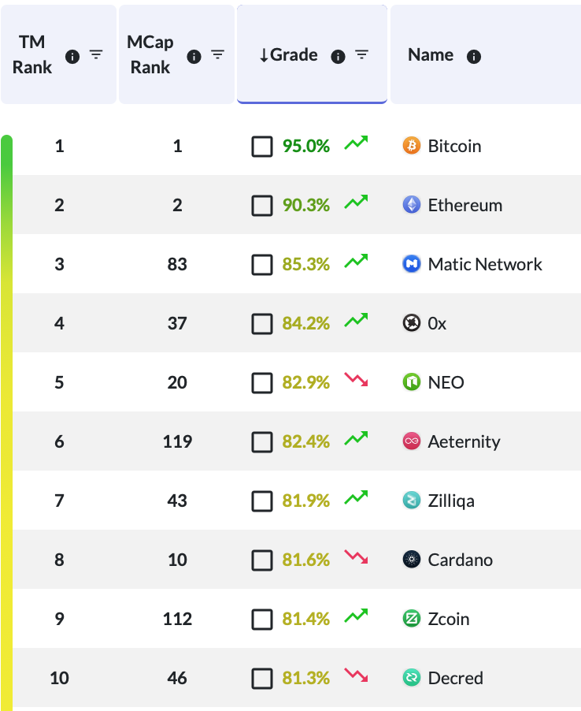

1. Using Rankings

**a) Absolute views:** **∆ = (MCap rank) - (TM rank)**

For assets with **∆ < 0**: I expect the performance of asset_i: **(∆) / sum (%)** (increase)

For assets with **∆ > 0:** I expect the performance of asset_i: **(-∆) / sum (%)** (decrease)

For assets with **∆=0:** No view

|  |  |  |
| --- | --- | --- |
| **Token** | **∆** | **View** |
| BTC | 0 | No view |
| ETH | 0 | No view |
| MATIC | 80 | E(r) = 19% |
| 0x | 33 | E(r) = 7.8% |
| NEO | 15 | E(r) = 3.6% |
| Aet | 113 | E(r) = 27% |
| Ziq | 36 | E(r) = 8.6% |
| ADA | 2 | E(r) = 0.5% |
| Zcoin | 103 | E(r) = 25% |
| DEC | 36 | E(r) = 8.6% |
| **TOTAL** | 418 |  |

**b) Relative views:**

For **∆_(i) > ∆_(i+1)** : asset_(i) will outperform asset_(i+1) by **(** **∆_(i) - ∆_(i+1) )/sum (%)**

For **∆_(i) < ∆_(i+1)** : asset_(i) will underperform asset_(i+1) by **(** **∆_(i+1) - ∆_(i) )/sum (%)**

1. Using grades (total or fundamental or technology)

Weight_score = Score_i / Total_score

Let **𝚪 = weight_score_i - weight_score_(i+1)**

**a) Absolute views**

I expect the performance of asset_i to be **weight_score_i (%)**

|  |  |  |
| --- | --- | --- |
| **Token** | **weight_score** | **View** |
| BTC | 11.2% | E(r) = 11.2% |
| ETH | 10.6% | E(r) = 10.6% |
| MATIC | 10.1% | E(r) = 10.1% |
| 0x | 9.95% | E(r) = 9.95% |
| NEO | 9.87% | E(r) = 9.87% |
| Aet | 9.73% | E(r) = 9.73% |
| Ziq | 9.68% | E(r) = 9.68% |
| ADA | 9.64% | E(r) = 9.64% |
| Zcoin | 9.62% | E(r) = 9.62% |
| DEC | 9.62% | E(r) = 9.62% |
| **TOTAL** | 846.3 |  |

**b) Relative views**

For **𝚪 > 0:** I expect asset_i to outperform asset_(i+1) by **𝚪 (%)**

For **𝚪 < 0:** I expect asset_i to underperform asset_(i+1) by -**𝚪 (%)**

1. Using Price Predictions

Use price predictions to get 30-day expected return for each asset **R_i**

**a) Absolute views**

I expect the performance of asset_i: **R_i (%)**

Confidence of view = accuracy of price prediction model of asset_i

|  |  |  |
| --- | --- | --- |
| **Token** | **30-day return prediction** | **View** |
| BTC | -20% | E(r) = -20% |
| ETH | -13% | E(r) = -13% |
| MATIC | 10% | E(r) = 10% |
| 0x | 2% | E(r) = 2% |
| NEO | 33% | E(r) = 33% |
| Aet | -45% | E(r) = -45% |
| Ziq | 9% | E(r) = 9% |
| ADA | 20% | E(r) = 20% |
| Zcoin | -1% | E(r) = -1% |
| DEC | 4% | E(r) = 4% |
| **TOTAL** | 846.3 |  |

**b) Relative views**

**For R_i > R_(i+1):** I expect asset_i to outperform asset_(i+1) by **( R_i - R_(i+1) ) %**

**For R_i < R_(i+1):** I expect asset_i to underperform asset_(i+1) by **(R_(i+1) - R_i) %**

1. Using TA Trend

To be able to incorporate the TA Trend to the views, we should quantify the difference between “Very Bullish” - “Bullish” - “Neutral” - “Bearish” - “Very Bearish”. So we need to use a TA Trend percentage grade and do the same as in (2).

Thoughts

* Make portfolio of top 30 crypto by TM ranking, and use the price prediction models to input an absolute view for each crypto.   
    
  Example: price prediction of BTC says we expect 20% return over next 30-days with accuracy of 80%, so input absolute view:   
  *I expect BTC to increase by 20% with confidence 80%. (or underestimate confidence)*In addition to that, we could use the monthly TA Trend to input relative views:  
  *Also, I expect BTC (“Very Bullish=94% and weight_score = 20%) to outperform ETH (“Neutral=75%” and weight_score=10%) by 10%.*
* For each index we make, we can add absolute and relative views using any of the scores, metrics, price predictions.

## Example Implementing the Price-Prediction Absolute Views for top20

## Index of Top20 by Mcap, using price predictions as views

|  |  |  |  |  |  |
| --- | --- | --- | --- | --- | --- |
| Coin | Original Weight | E(r) (monthly) Stdev | Views | Rebalance | Opt weights |
| ADA | 0.4% | 10.7%  11.5% | -27% | -9.7% | **-9%** |
| BCH | 1.8% | 5.9% 2.5% | -34% | -12% | **-10%** |
| BNB | 1.1% | 4.8% 1.7% | +11.3% | +3.6% | **4.8%** |
| BSV | 0.9% | 4.4% 1.7% | -33.5% | -12% | **-11%** |
| BTC | 74.2% | 6% 2.3% | -0.1% | -4% | **70%** |
| DEV | 0.8% | 52% 590% | +1% | -0.98% | **-0.2%** |
| EOS | 1.1% | 5.5% 2.6% | +1% | -0.01% | **1%** |
| ETH | 7.8% | 6.6% 3.3% | -33% | -12% | **-4%** |
| HT | 0.3% | 4.1% 1.7% | +11.5% | +3.76% | **4%** |
| LBC | 0.5% | 7.7% 14.4% | +1% | -0.2% | **0.2%** |
| LEO | 0.4% | -0.1% 0.5% | -34% | -12% | **-11%** |
| LTC | 0.1% | 5.5% 2.3% | +30% | +10.3% | **10.5%** |
| MIN | 0.4% | 8.1% 42.5% | +1% | -0.6% | **-0.2%** |
| TAGZ5 | 1.5% | 68% 1280% | +1% | -1.6% | **-0.1%** |
| TRX | 0.4% | 7.7% 4% | -12.5% | -4.7% | **-4%** |
| USDT | 2% | 0.3% 0.04% | +2% | +0.56% | **2.5%** |
| XLM | 0.6% | 5.5% 3.6% | -34% | -11.9% | **-11%** |
| XMR | 0.5% | 5.1% 2.6% | -34% | -12.3% | **-11.8%** |
| XRP | 4.2% | 3.9% 1.2% | +10% | +3.1% | **7.3%** |

|  |  |  |  |  |  |
| --- | --- | --- | --- | --- | --- |
| XTZ | 0.4% | 5.6% 3.3% | +1% | +0.1% | **0.5%** |

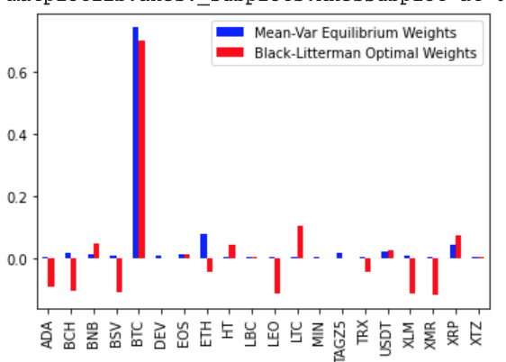

## Index top20 TM rank, using delta as views (Value investor)

|  |  |  |  |  |  |  |
| --- | --- | --- | --- | --- | --- | --- |
| Coin | Mcap rank | Initial weight | **∆** | Views | Rebalance | Opt weight |
| 1-BTC | 1 | 82.80% | 0 | No view | -4% | 78% |
| 2-ETH | 2 | 12.44% | 0 | No view | -0.69% | 11.7% |
| 3-MATIC | 88 | 0.03% | 85 | +9.2% | +1.7% | 1.8% |
| 4-MKR | 28 | 0.22% | 24 | +2.6% | -1.38% | -1.1% |
| 5-STX | 90 | 0.03% | 85 | +9.2% | +0.52% | 0.62% |
| 6- ATOM | 25 | 0.24% | 19 | +2.1% | -0.71% | -0.46% |
| DASH | 22 | 0.32% | 15 | +1.6% | -1.44% | -1.1% |
| NEO | 20 | 0.35% | 12 | +1.3% | -2.38% | -2% |
| BNB | 8 | 1.19% | -1 | -0.1% | -2.2% | -1% |
| ZEC | 26 | 0.24% | 16 | +1.7% | -1.6% | -1.3% |
| AE | 119 | 0.02% | 107 | +11.5% | +2.7% | 2.8% |
| DCR | 49 | 0.08% | 36 | +3.9% | -0.62% | -0.5% |
| ADA | 9 | 1.12% | -5 | -0.5% | -2% | -0.9% |
| ZIL | 47 | 0.09% | 32 | +3.5% | -0.16% | -0.06% |
| WAVES | 67 | 0.06% | 51 | +5.5% | +1% | 1.1% |
| 0x | 38 | 0.12% | 21 | +2.3% | -0.47% | -0.35% |
| XMR | 16 | 0.55% | -2 | -0.2% | -2.69% | -2.1% |
| ZEN | 92 | 0.03% | 73 | +7.8% | +1.8% | 1.9% |

|  |  |  |  |  |  |  |
| --- | --- | --- | --- | --- | --- | --- |
| HOT | 74 | 0.04% | 54 | +5.8% | +0.36% | 0.46% |

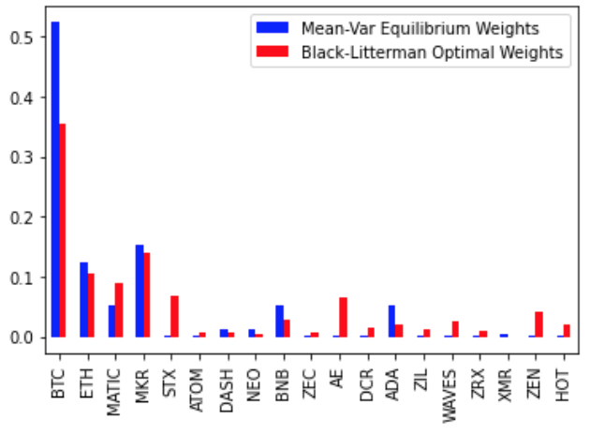

## Using Grades

I used the same 19 cryptos as before to not change the correlation matrix

|  |  |  |  |  |  |  |
| --- | --- | --- | --- | --- | --- | --- |
| Coin | Fundamental score | Initial weight | **∆** | Views = Score / SUM(Score) | Rebalance | Opt weight |
| BTC | 93.63% | 82.40% | +6.1% | +6.1% | -4.19% | 78.2% |
| ETH | 90.30% | 12.44% | +5.8% | +5.8% | -0.9% | 11.5% |
| MATIC | 83.16% | 0.1% | +5.4% | +5.4% | +0.17% | 0.27% |
| MKR | 80.87% | 0.22% | +5.2% | +5.2% | -0.4% | -0.18% |
| STX | 76.66% | 0.1% | +4.9% | +4.9% | +0.5% | 0.61% |
| ATOM | 81.27% | 0.24% | +5.2% | +5.2% | +0.06% | 0.3% |
| DASH | 81.83% | 0.32% | +5.3% | +5.3% | -0.25% | 0.06% |
| NEO | 76.08% | 0.35% | +4.9% | +4.9% | -0.735% | -0.38% |
| BNB | 77.58% | 1.19% | +5.0% | +5.0% | -0.38% | +0.8% |
| ZEC | 86.57% | 0.24% | +5.6% | +5.6% | -0.30% | -0.06% |
| AE | 76.70% | 0.1% | +4.9% | +4.9% | +0.05% | 0.15% |
| DCR | 82.65% | 0.1% | +5.3% | +5.3% | -0.21% | -0.11% |
| ADA | 72.73% | 1.12% | +4.7% | +4.7% | -0.29% | 0.83% |
| ZIL | 76.57% | 0.1% | +4.9% | +4.9% | -0.01% | 0.085% |
| WAVES | 77.69% | 0.1% | +5.0% | +5.0% | +0.29% | 0.39% |
| 0x | 80.88% | 0.12% | +5.2% | +5.2% | +0.16% | 0.284% |
| XMR | 86.90% | 0.55% | +5.6% | +5.6% | -0.5% | 0.04% |
| ZEN | 69.03% | 0.1% | +4.4% | +4.4% | +0.22% | 0.32% |
| HOT | 88.67% | 0.1% | +5.7% | +5.7% | -0.01% | 0.09% |

